Dated 04—3-2024

<https://www.youtube.com/watch?v=uYlbaTAI3G8&list=PLBx2L_ikudBO7s6SQZaMDCtbyrjQ-04a8>

Saima academy

**Python: Exploring the Jupyter Notebook: Lesson 3 in Urdu/ Hindi Saima Academy**

**print("Hi students")**

**Python: Lesson 6: Jupyter Notebook, How to Edit, Run and Save Urdu/ Hindi Saima Academy**

**Python: Lesson 7: Jupyter Notebbok: Insert cells & Reset the Kernel Urdu /Hindi Saima Academy**

**To change python**

**What are variables**

**Comment in python**

**Initialising variables**

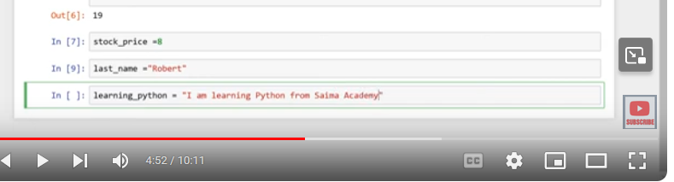**

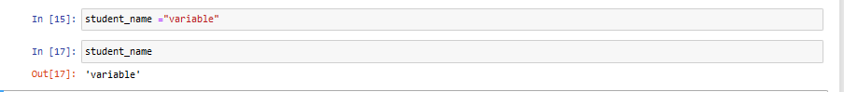

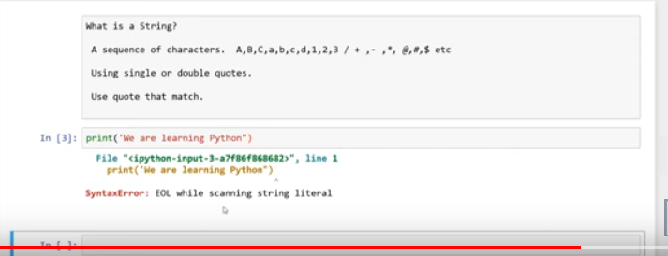

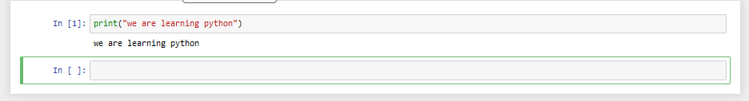

**This is a string datatypes**

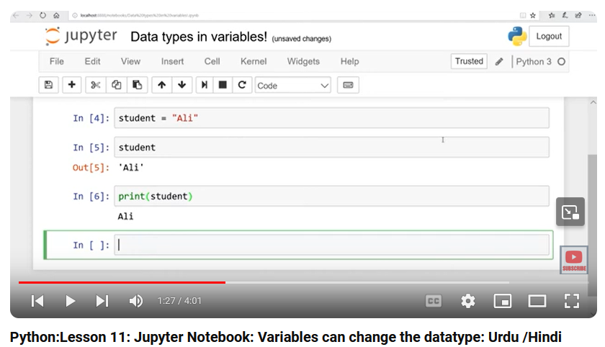

**Integer datatypes**

**Float datatypes**

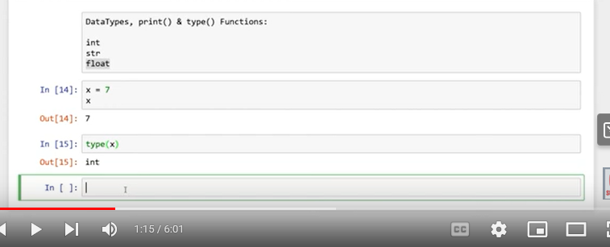

**This is Float datatypes.**

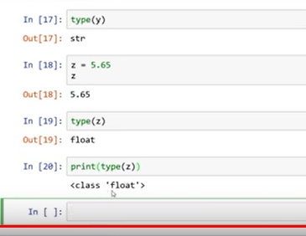

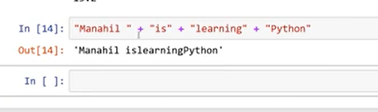

**Need to give space in inverted commas**

**Below is variable and literals**

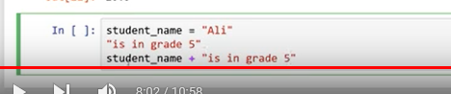

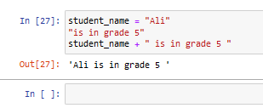

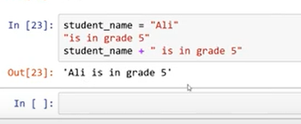

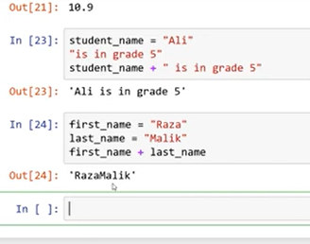

**This is two variables**

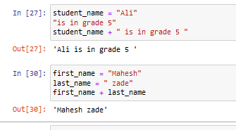

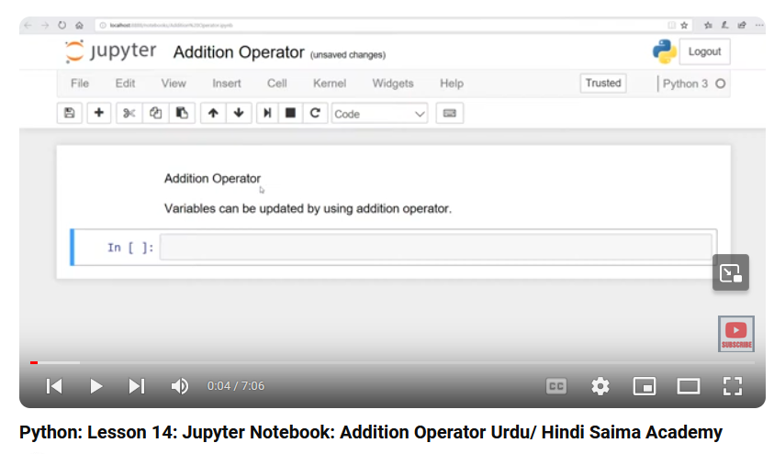

**Addition of operator**

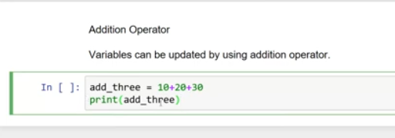

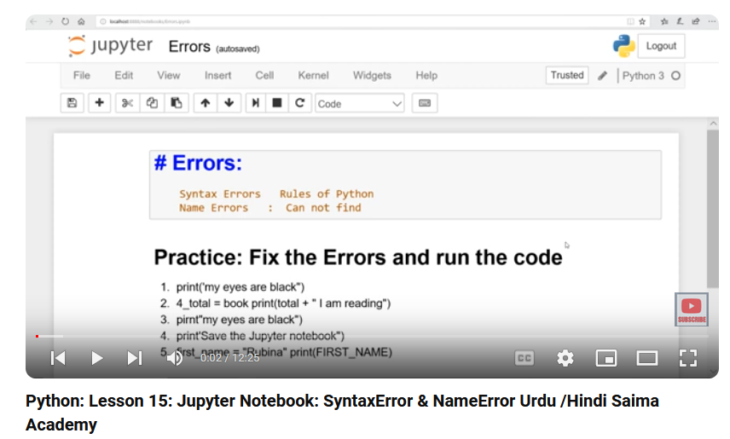

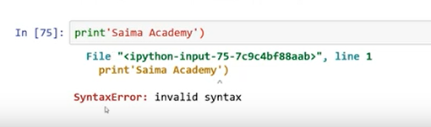

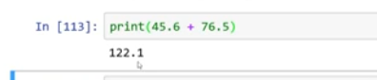

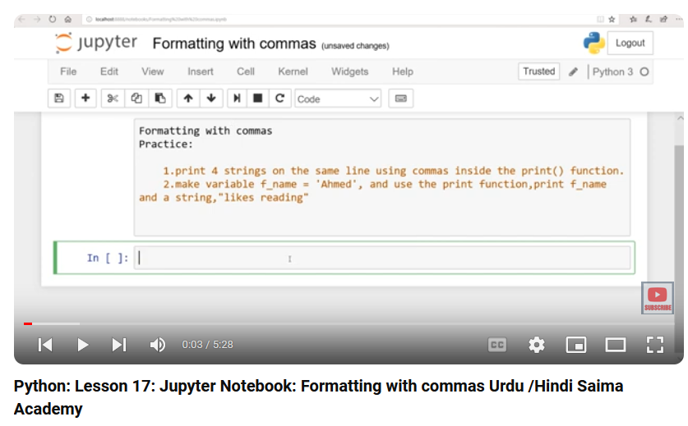

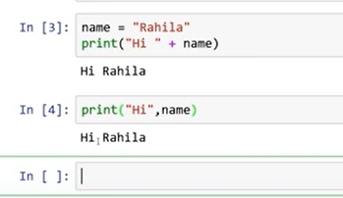

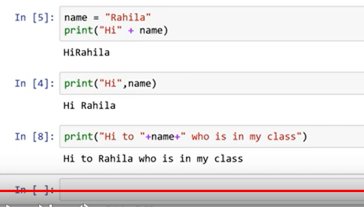

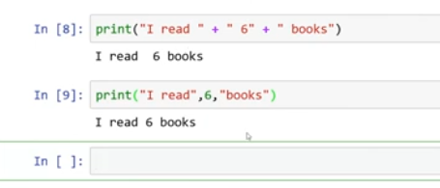

Integer and string can concatenate by commas ,

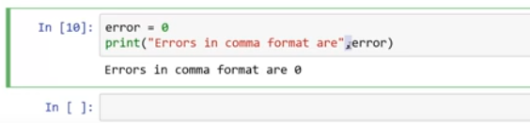

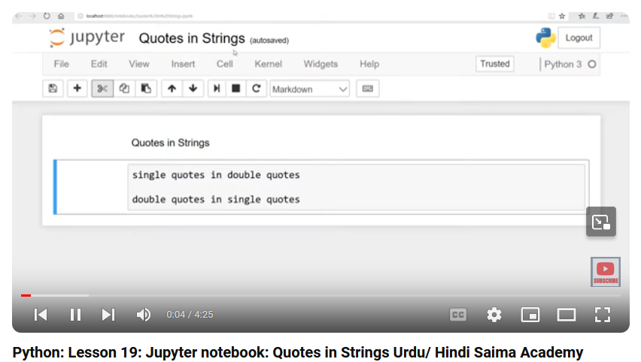

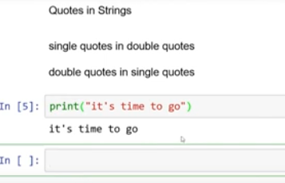

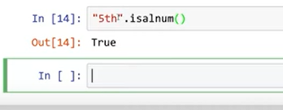

.istitle() me each word starts with capital letter

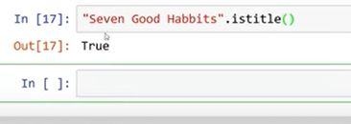

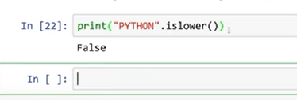

.lower type

Printed in capital only

Second option to print

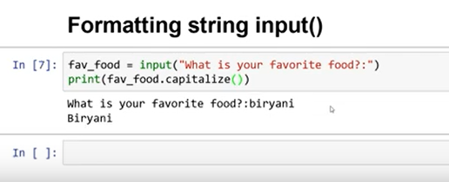

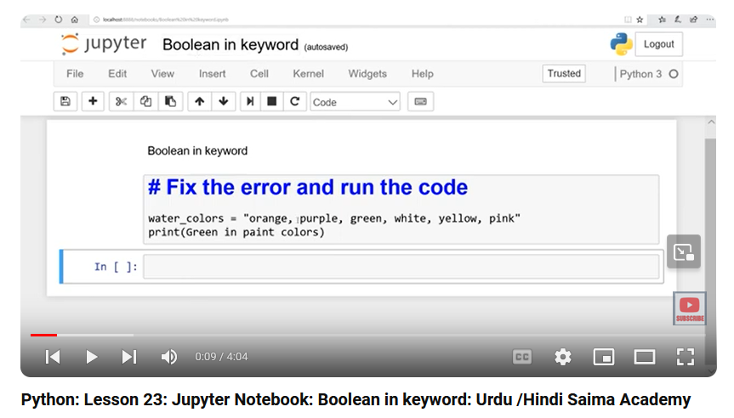

Need to write case sensitive pen user in keyword

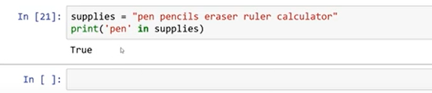

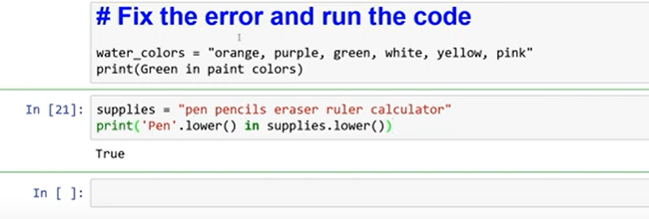

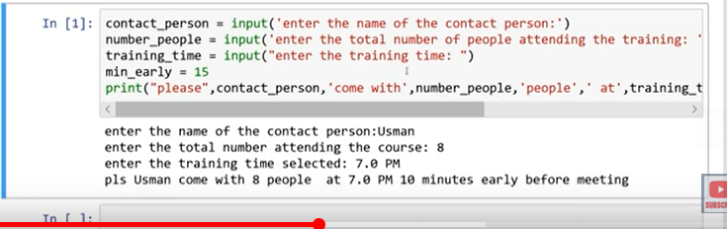

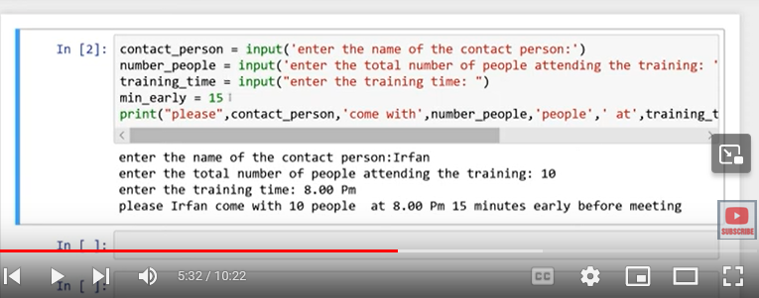

With input and without input value is changing and fixed

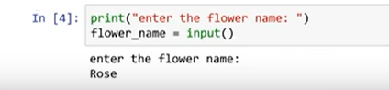

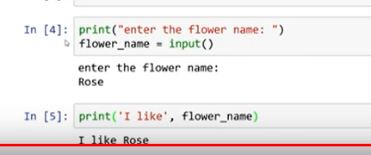

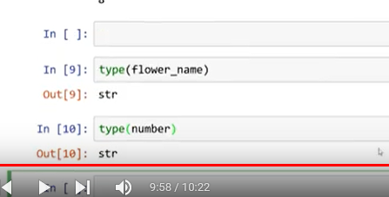

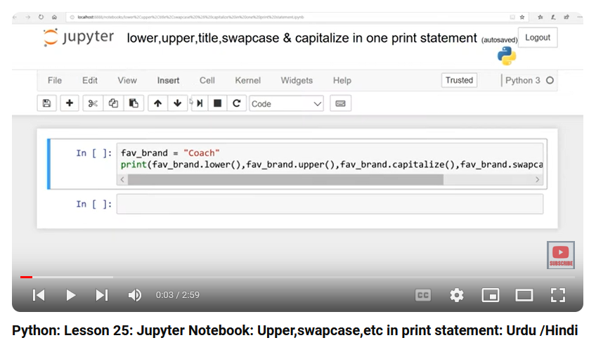

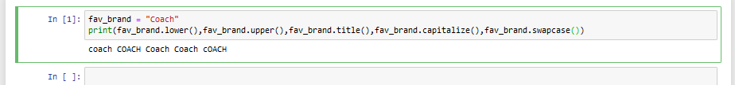

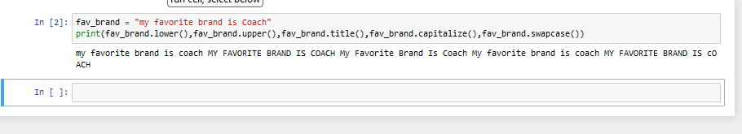

Put comma for arguments

